

MUMBAI EDUCATIONAL TRUST
MET INSTITUTE OF COMPUTER SCIENCE

Program Number | 08
Roll Number | 1550
Title of program | Pig commands
Objective | Pig commands
Download and Install Pig 16.0
Copy download file create new folder piu pig-0.16.0 tar .gz
Cd piu
// x- v- f-file
tar -xvf pig-0.16.0.tar.gz
ls //look 2 folder
cd // outside the home
gedit .bashrc
//file is open if path is not set //home/cloudera/piu/pig-0.16.0
//home/cloudera/piu/pig-0.16.0/bin

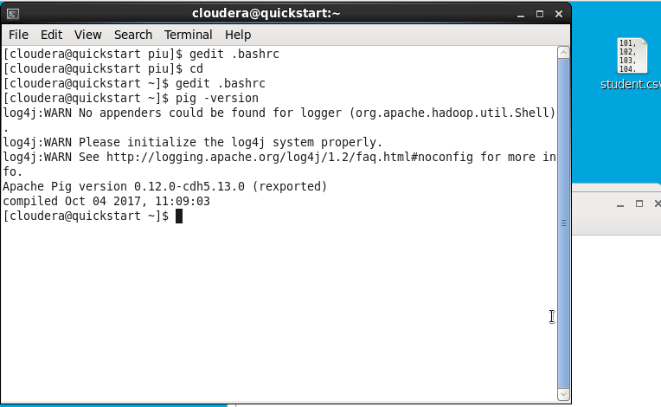
Enter pig for grunt shell
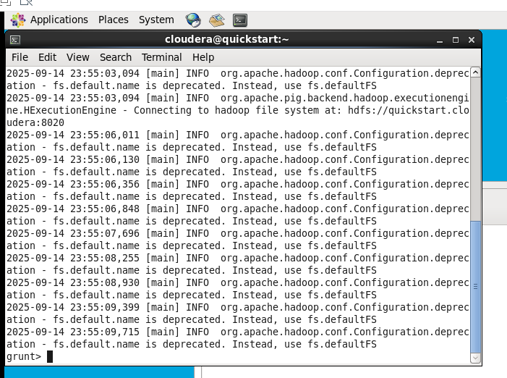

create a csv file..enter data into it…load the data into hdfs…then into pig and it will
convert the mapreduce jobs.
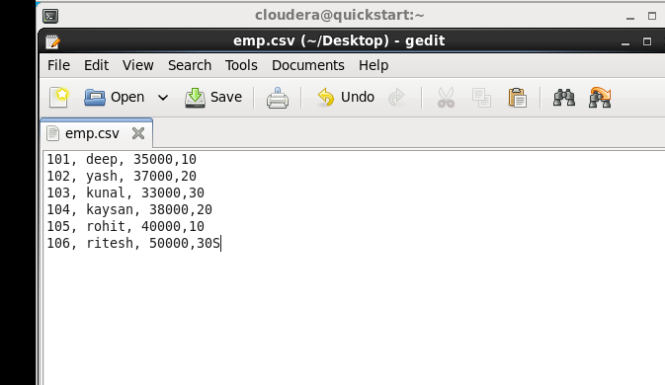
30s is mistake is 30
Open new terminal
cd Desktop
hdfs dfs -copyFromLocal emp.csv /user/cloudera/
hdfs dfs -ls

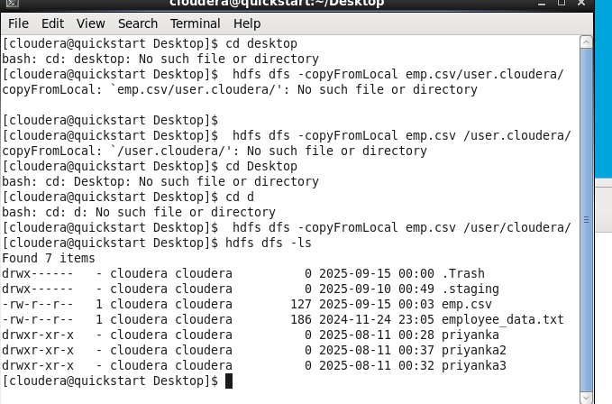
Again come to grunt shell
empdata = load ‘/user/cloudera/emp.csv’;
dump empdata;

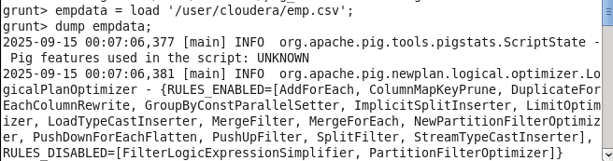
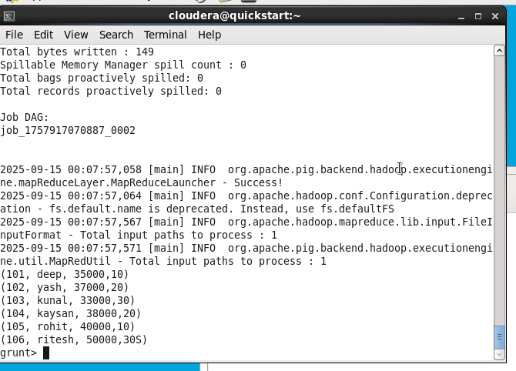

Q1)Write a query to sort the data according to salary.
empdata2 = load ‘/user/cloudera/emp.csv’ using PigStorage(‘,’) as
(empid:int,ename:chararray,sal:int,dept:int)
orderbysal = ORDER empdata2 by sal ;
dump ORDER empdata2 by sal;

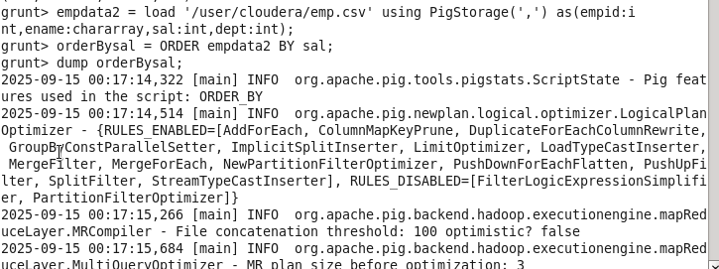
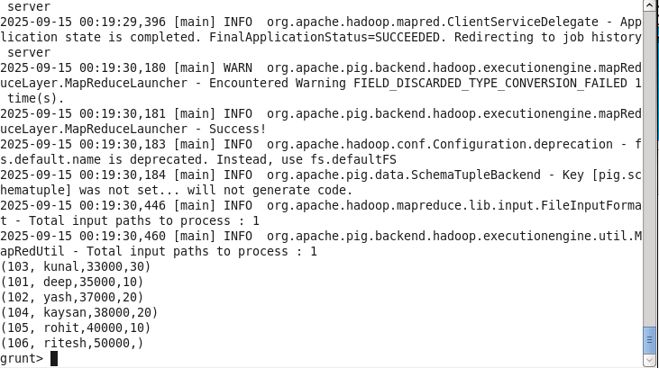

Q2) Write a query to sort the data according to salary in Descending order.
orderbysal = ORDER empdata2 by saldesc ;
dump ORDER empdata2 by sal;

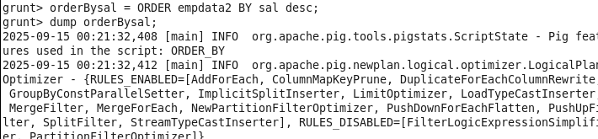
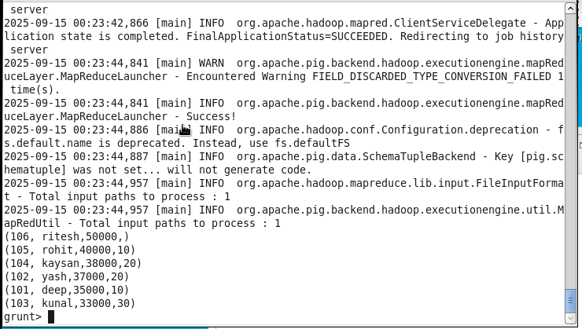

Q3.Write a query in pig to find maximum salary in each department.
grpbydept = GROUP empdata2 by dept;
dump grpbydept;

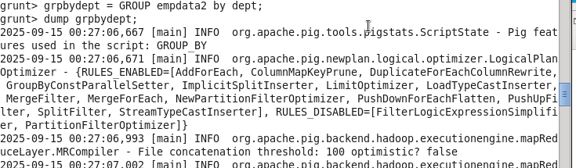
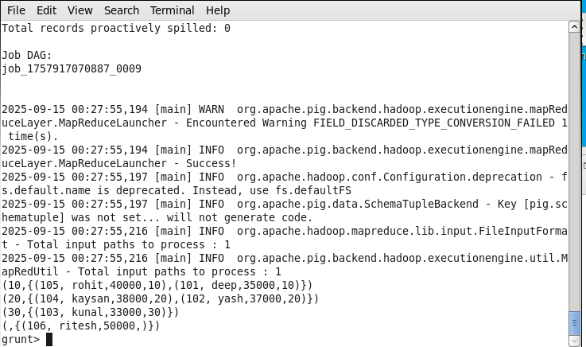

Q4)Write a query to display count of employees in each department.
cntEmp = FOREACH grpbydept GENERATE COUNT(empdata2);
dump cntEmp;
